**PLUS choose ONE of the following amenities:**

**•Free Prepaid Gratuities for Two**

**•$300 Onboard Cabin Credit**

**•Free Classic Beverage Package for Two**

**(includes sodas, alcohol, 15% gratuity)**

**Offer Expires Oct. 5, 2015**

**Thomas Hogan Travel – “Your Group, Tour, & Cruise Travel Experts”**

**1801 Oak St., Myrtle Beach, SC 29577 • 843-626-9998** • [www.thomashogan.com](http://www.thomashogan.com)

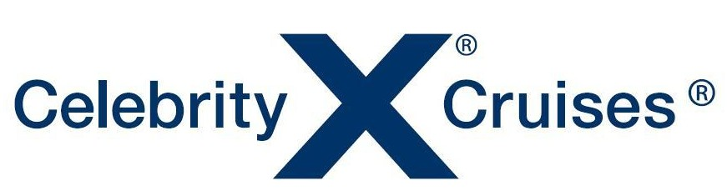

17- **NIGHT PANAMA CANAL CRUISE**

***from* Ft. Lauderdale to San Francisco**

**I**ncluding overnight in Cabo San Lucas

***onboard the* Celebrity Infinity**

**April 28 – May 15, 2015**

**$4050.00 per person /Balcony Cabin**

**$3300.00** **per person/Outside Cabin**

**INCLUDES:**

***Roundtrip airfare from Myrtle Beach, ground transfers, and all taxes.***

|  |  |  |  |
| --- | --- | --- | --- |
| Date | Ports of Call | Arrive | Depart |
| TUE 28APR | **Fort Lauderdale** |  | **04:30 PM** |
| WED 29APR | **At Sea** |  |  |
| THU 30APR | **At Sea** |  |  |
| FRI 01MAY | **Cartagena, Colombia** | **07:00 AM** | **03:00 PM** |
| SAT 02MAY | **Colon, Panama** | **09:00 AM** | **07:00 PM** |
| SUN 03MAY | **Panama Canal (Cruising Canal)** | **06:00 AM** | **06:00 PM** |
| MON 04MAY | **At Sea** |  |  |
| TUE 05MAY | **Puntarenas, Costa Rica** | **08:00 AM** | **08:00 PM** |
| WED 06MAY | **At Sea** |  |  |
| THU 07MAY | **Puerto Quetzal, Guatemala** | **07:00 AM** | **06:00 PM** |
| FRI 08MAY | **At Sea** |  |  |
| SAT 09MAY | **At Sea** |  |  |
| SUN 10MAY | **Puerto Vallarta, Mexico** | **07:00 AM** | **02:30 PM** |
| MON 11MAY | **Cabo San Lucas, Mexico** | **07:00 AM** | **-------------** |
| TUE 12MAY | **Cabo San Lucas** | **------------** | **04:00PM** |
| WED 13MAY | **At Sea** |  |  |
| THU 14MAY | **At Sea** |  |  |
| FRI 15MAY | **San Francisco** | **7:00am** |  |

**A deposit of $550.00 per person is required at the time of booking • Final balance is due Feb. 3, 2015**